Ocean Alkalinity Enhancement and Seasonality in the Ocean Carbon System (title tbc)

Points and Qs
- What are the implications of changing seasonality due to OAE? Are they relevant (compared to what - present day and also future state in a high-emissions world)?
- Could OAE driven changes in seasonality provide guardrails for the way OAE is deployed (in addition to guardrails searched for so far that have not explicitly considered seasonality)?
- Could seasonality be used to better detect and monitor OAE?
- Is the change symmetrical or asymmetrical in each scenario? (i.e. annual average source or sink not changing or changing?)
- Generally speaking what are the seasonal dynamics related to OAE in the two regions
- MRV is hard
  - Small signals, difficulties with measuring alkalinity
- Seasonal cycle has been found to be relevant for detectability (Wang et al.)
- Seasonality is changing
- How do these things all come together to make this paper relevant

Abstract
BACKGROUND
- MRV for OAE complicated by small signals against large variability, including seasonal cycles in carbonate system
- Compounded by increasing seasonal cycles in pCO2
Monitoring, reporting and verification (MRV) of ocean alkalinity enhancement (OAE) is a complex issue. One complicating factor is the fact that drawdown of carbon due to OAE produces a small signal in the carbonate system that is easily obscured by natural variability, including seasonal cycles in the carbonate system. This issue is compounded by the expectation that seasonal cycles in the carbonate system are expected to increase as atmospheric CO₂ and ocean temperatures both increase.
We examine how OAE alters the amplitude and timing of the seasonal shifts in marine carbonate chemistry compared to a control scenario with no OAE, and consider whether these changes are relevant compared to both present day and future changes following high-emissions scenarios. We also consider the implications of changing seasonality for MRV efforts, including whether changes to the seasonal cycle can be used as an MRV metric, or guardrails to guide how OAE is implemented in the future. Using an Earth System Model (FOCI; Matthes et al. 2020; Chien et al. 2022), we conduct this analysis on scenarios with alkalinity added along the European coastlines exposed to the North Sea, and with alkalinity added in the Chinese EEZ.

Intro
In order to maintain pathways towards the commonly agreed targets of 1.5 and 2C (UNFCCC, 2015), some degree of carbon dioxide removal (CDR) is necessary alongside strict and lasting emissions reductions. CDR methods exist on a spectrum of feasibility and desirability, and can be considered in two categories: conventional, i.e. those which are already being applied at some scale, and novel - where the technology required is still nascent compared to conventional methods (Smith et al. 2024). Conventional methods include afforestation/reforestation and other land management solutions such as peatland and coastal wetland restoration, as well as durable wood products and soil carbon sequestration (Smith et al. 2024). Although 99.9% of current CDR is done via conventional methods, pathways of CDR that are consistent with limiting warming to 1.5 or well below 2C (cite Paris Agreement) require a scale-up of novel CDR methods until they contribute a median of X% of total CDR by [what year] (Smith et al. 2024). Marine CDR (mCDR) makes up part of the suite of novel methods. All mCDR methods work by changing carbonate balance in the layer of the ocean in contact with the atmosphere. As long as this water remains in contact with the atmosphere, this is followed by ocean-atmosphere pCO₂ re-equilibration, leading to drawdown of atmospheric CO₂.
mCDR holds promise because the ocean is already a powerful carbon sink in the Earth system, absorbing around a quarter of anthropogenic carbon emissions in 2022 (Friedlingstein et al. 2023). Ocean alkalinity enhancement (OAE) is one form of novel CDR that shows potential for high sequestration of 3-30GtCO₂/year on timescales from tens to hundreds of thousands of years (Oschlies et al. 2023). Carbon sequestration is achieved by making seawater more alkaline, thus shifting the balance of DIC species so that aqueous CO₂ decreases. This increases the air-sea pCO₂ gradient and (ideally) causes increased air-sea CO₂ flux as the atmosphere and ocean re-equilibrate. This method is only effective to draw down carbon as long as the alkaline water remains in the mixed layer (therefore in contact with the atmosphere) - once the alkaline water is mixed into the deeper ocean, it can no longer re-equilibrate with the atmosphere. However, the storage of carbon is long lasting, because it is stored in forms of DIC that do not impact the air-sea pCO₂ gradient (i.e., not as aqueous CO₂).
There are several complicating factors relating to monitoring, reporting and verification (MRV) specifically for OAE. Firstly, perturbations related to OAE are necessarily small to avoid negative ecological impacts, and are further diluted due to both lateral and vertical ocean mixing. This presents a challenge for MRV because the perturbations to the system may become too small to be measured by conventional equipment (Ho et al. 2023). Secondly, the changes made to the marine carbonate system do not necessarily mean that a corresponding amount of CO₂ will be drawn down from the atmosphere, if there is insufficient time for re-equilibration. This presents an issue for MRV because just measuring instantaneous changes to the carbonate system does not necessarily tell the complete story of atmospheric carbon drawdown, and any drawdown that does occur may only leave a small signal compared to the signal of natural variability. Whether and how this signal can be detected is a significant challenge to MRV.
- More about MRV and how seasonality is an important part of the story
  - Cyronak et al. 2023 - field experiments
The impact of variability on the detectability of the signal from alkalinity enhancement is therefore an important consideration for MRV. However, implementing alkalinity addition to maximise detectability can come with trade-offs for ecological safety. Wang et al. (2025) found that seasonal variation should be considered to optimise the timing of alkalinity addition. They found that adding alkalinity during the summer months maximised the detectability of the alkalinity addition, but also lengthened the mean residence time of the extra alkalinity, potentially increasing the ecological impacts.
Therefore, it is important to understand seasonal variability, partly for robust MRV systems for OAE and partly to ensure effective and responsible deployment. This has been shown to be important in terms of the timing of addition, but there has (to date) been minimal research on the implications of the change in seasonality caused by alkalinity enhancement, and whether this is also worth considering in MRV frameworks. In this study, we examine how ocean alkalinity in two different regions (the North Sea and South/East China Seas) impacts the seasonality of carbon chemistry in the region of addition. We chose these two regions for comparison because of their different circulation patterns, with the North Sea coastlines being more exposed to lateral mixing, and the South/East China Seas EEZ being subject to more sluggish and enclosed circulation. They are also both areas with dense populations and infrastructure that can facilitate deployment of OAE. We assess whether coastal OAE implementation brings the seasonal cycle in the carbonate system closer to, or further away from, pre-industrial conditions. We consider both changing amplitude and phase shift in the seasonal cycle, and address the following three questions in our discussion:
- What are the implications of changing seasonality due to OAE?
- Could OAE-driven changes in seasonality provide additional guidance for the way OAE is deployed, both spatially and temporally?
- Could changes to the seasonal cycle be used to better detect and monitor OAE?

Location background
- SCS: Ocean nets highest deployment, sluggish circulation
- Plattner et al. 2001, Roy et al. 2011: N Atlantic region of largest climate-induced reduction of CO2 uptake (check more recent sources)
- Check uptake estimates for SCS or this area of Pacific
- Takahashi et al. 2009 - NA accounts for about ⅓ of global CO2 uptake (check again for more recent estimates)
- Goris et al. 2018 - future uptake in North mid-high lats dominated by transport across Southern boundary
- S/ECS background (Chai et al. 2009)
  - Temperature dominated seasonal cycle
  - Net source in spring, summer and autumn; sink in winter (net: weak source)
  - Teleconnected to Pacific East-Asian large-scale climatic variability
  - Airflow: monsoon seasonality
  - Circulation: Northern part of SCS cyclonic gyre year-round (upwelling)

Methods
We use the Flexible Ocean and Climate Interface (FOCI; Matthes et al. 2020) coupled with the Model of Ocean Pelagic Stoichiometry (MOPS; Kriest and Oschlies, 2015). The performance of this coupling is assessed in Chien et al. (2022). The FOCI model is a fully coupled ocean/sea-ice/atmosphere general circulation model, coupling the Nucleus for European Modelling of the Ocean (NEMO; Madec and the NEMO team, 2016) for ocean and sea ice, the Jena Scheme for Biosphere–Atmosphere Coupling in Hamburg (JSBACH; Brovkin et al., 2009; Reick et al., 2013) for land and the ECHAM6.3-HAM2.3-MOZ1.0 (ECHAM6-HAMMOZ; Schultz et al., 2018) for atmosphere. The coupling with the MOPS model allows for simulation of marine biogeochemical processes, including marine carbon, nitrate (NO₃), phosphate (PO₄), and oxygen (O₂) cycles. The model is run at 0.5x0.5 degree resolution on a global tripolar grid (to avoid a singularity at the North Pole), and the region(s) of study are extracted at the end of the model run. [spinup], the model is then run until 2100, outputting data at a monthly resolution.
For this study, we consider alkalinity addition in two regions, shown in Figure (x): the exposed coastlines of the North Sea/North Atlantic, and the South/East China Seas Exclusive Economic Zone (EEZ). The model simulation begins in 2015, with alkalinity addition starting in 2025. Alkalinity is added in the two regions according to scenarios devised using feasible amounts of quicklime (Lezaun et al. 2024), but in practice this is modelled by simply adding total alkalinity in each grid square in the surface layer of the ocean. The amount of alkalinity added in each zone is linearly ramped up over the next 10 years until it reaches an amount consistent with 1 Gigatonne of quicklime per year over the entire zone of addition, and is then held constant until 2100. Alkalinity is added at every time step in the model so addition is modelled as effectively continuous, and monthly output is used for analysis. Because the total area of addition in each location is different (figure y) but the amount of quicklime is the same, the flux of alkalinity is different in each region: 1.4 𝞵molC/m²/year in the North Sea, 0.8 𝞵molC/m²/year in the South/East China Seas. In each simulation, background emissions follow SSP3-7.0. To analyse the data, we mainly consider surface characteristics because alkalinity is added at the surface, so this is where the signal will be strongest.

Results
We begin by illustrating the impact of mixed layer depth on the signal of OAE from the modelled constant alkalinity addition. In both cases, a deeper mixed layer over winter dilutes the added alkalinity over greater depths. As the mixed layer shoals in the summer, the added alkalinity is concentrated in shallower waters. There is also some escape of alkalinity in the winter into deeper waters, lowering the efficiency of CO₂ drawdown as this alkalinity is taken out of contact with the atmosphere before any re-equilibration. Any alkalinity that is re-entrained the next winter would add to the added alkalinity that year. \SCS_mxl and \EU_mxl show this for the South/East China Seas and the North Sea/North Atlantic, respectively. The mixed layer seasonality in the South/East China Seas is less than the seasonality in the North Sea/North Atlantic (an amplitude of up to 30m in the South/East China Seas and up to 110m in the North Sea/North Atlantic), so the seasonality in the signal of alkalinity addition in the North Sea/North Atlantic has a corresponding higher amplitude - this is visible in the contrast of colours in figures \EU_mxl and \SCS_mxl, denoting the difference in added alkalinity between winter and summer.
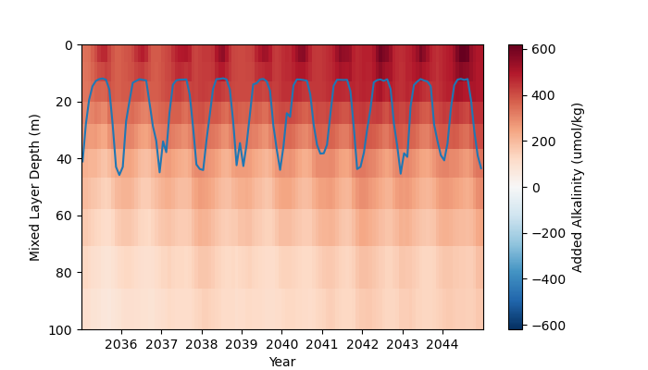
\SCS_mxl: South/East China Seas area-averaged added alkalinity (total alkalinity in OAE simulation minus counterfactual simulation) within the region of addition over depth, mixed layer depth (defined using potential density) taken from the alkalinity addition simulations in blue.

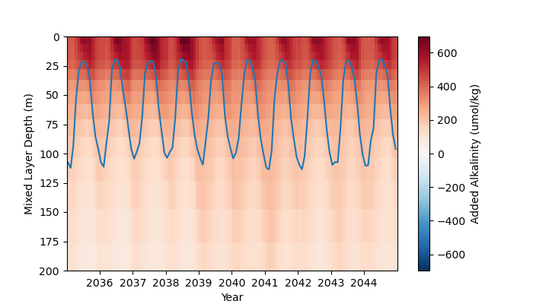
\EU_mxl: North Sea/North Atlantic area-averaged added alkalinity (total alkalinity in OAE simulation minus counterfactual simulation) within the region of addition over depth, mixed layer depth (defined using potential density) taken from the alkalinity addition simulations in blue.
In terms of the effect that this seasonality has on the seasonality in the ocean carbonate system we know from figures \EU_mxl and \SCS_mxl that the impact of adding alkalinity will be stronger in the summer, when the mixed layer is shallower. In the region where alkalinity is added, this asymmetry in alkalinity addition between winter and summer is enough to reverse the seasonal cycle in alkalinity, pH and CO₂ fugacity (fCO₂) in the North Sea/North Atlantic, and severely dampens the seasonal cycle in pH and fCO₂ in the South/East China Seas. This is visible in Figures \SCS_cycle_alkdicphfco2 and \EU_cycle_alkdicphfco2, which show the seasonal cycle in alkalinity, DIC, pH and fCO₂ in the preindustrial era (black), 2015-2020 (solid), 2035-2040 (dashed) and 2095-2100 (dotted) in the addition simulations. However, the reaction of DIC is the opposite in each region, with DIC increasing but showing no change in the seasonal cycle in the South/East China Seas, but showing a weak reversal in the North Sea/North Atlantic region.
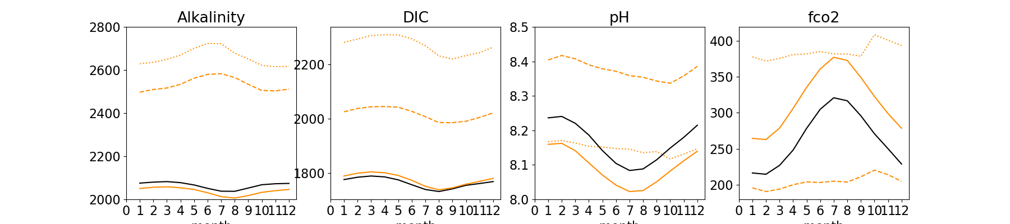
\SCS_cycle_alkdicphfco2
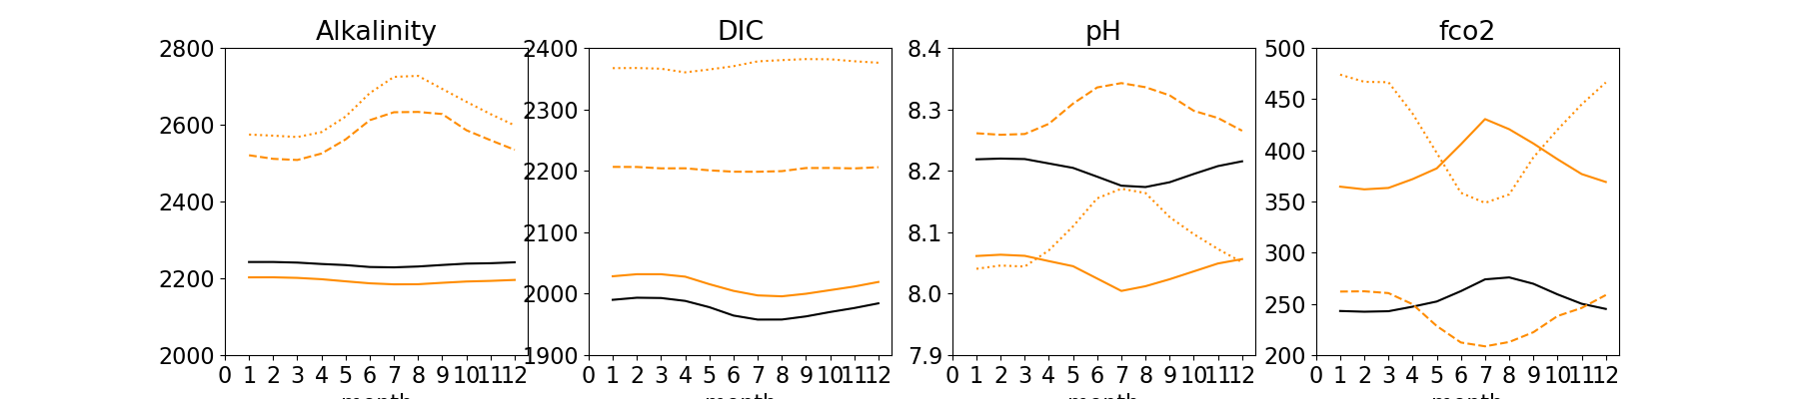
\EU_cycle_alkdicphfco2

We can also consider where the change in the magnitude of the seasonal cycle is significant compared to natural variability. To demonstrate this, figure \where_EU shows where, following alkalinity addition along the exposed European coastlines, the magnitude of the seasonal cycle (in 2100) lies outside three standard deviations of the seasonal cycle (in 2100) over the counterfactual simulation. Shading in yellow indicates that the seasonal cycle has significantly amplified, shading in blue indicates that the seasonal cycle is significantly dampened. [what are the implications of this?]
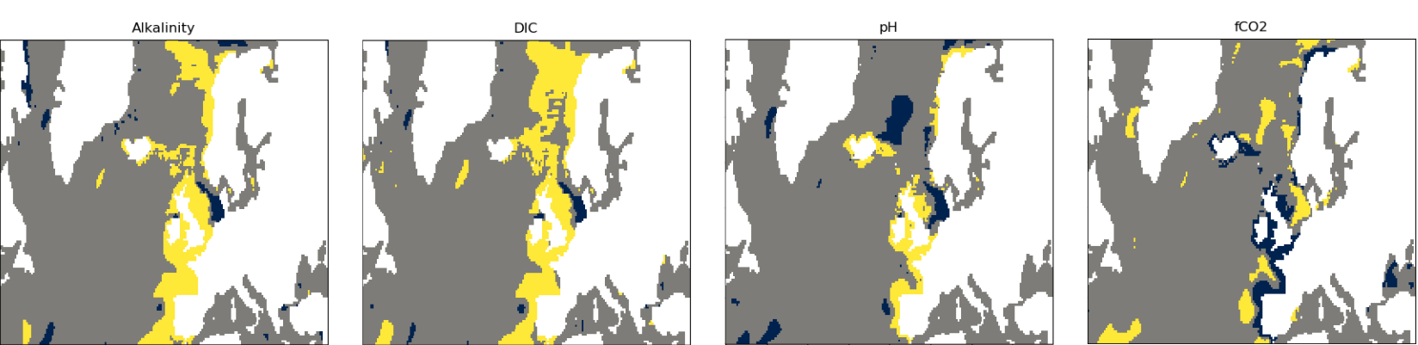
Figure \where_EU: parts of the study region where the amplitude of the seasonal cycle in 2095-2100 of the OAE simulation is more than three standard deviations away from the amplitude of the seasonal cycle in 2095-2100 of the counterfactual. The standard deviation is calculated over the entirety of the counterfactual simulation, for each grid point.
The panels in figure \where_EU show the change by the end of the century, after 75 years of alkalinity addition. Averaging over the area of addition, we can consider how long it takes for this trend to emerge. Figure \TOE shows the seasonal amplitude of the counterfactual simulation, with three standard deviations of the entire simulation shaded (blue). The point at which the mean seasonal amplitude (orange) leaves the envelope of three standard deviations can be considered the year at which the change in the seasonal cycle (averaged over the study region) becomes significant. For these figures, we plot the rolling average over 5 years and the associated standard deviation.
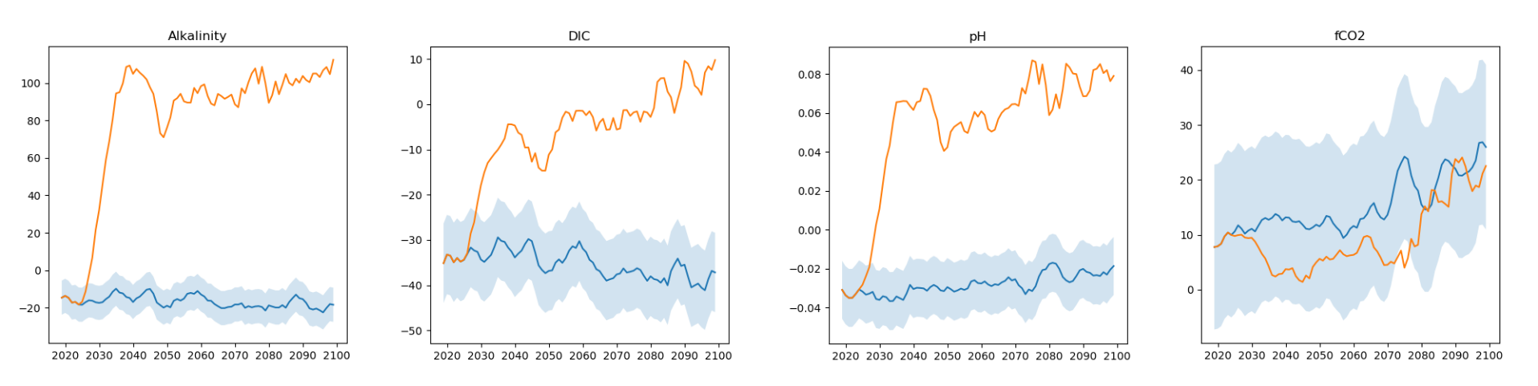
Figure \TOE: blue mean the seasonal amplitude in alkalinity, DIC, pH and fCO2 of the counterfactual (blue) and the OAE (orange) simulations, with three standard deviations of the counterfactual simulation shaded in blue. The point where the orange line leaves the blue shading can be considered the time of emergence of the trend in seasonality.
As well as the magnitude of the seasonal cycle, it is important to consider the phase shift caused by addition of alkalinity, which can be seen for all properties considered when alkalinity is added along the exposed European coastlines. Figure (pick one) shows the parts of the study area where the peak in the seasonal cycle has moved by more than three months (either from the beginning to the end of the simulation, or at the end of the simulation between the OAE and counterfactual simulations).
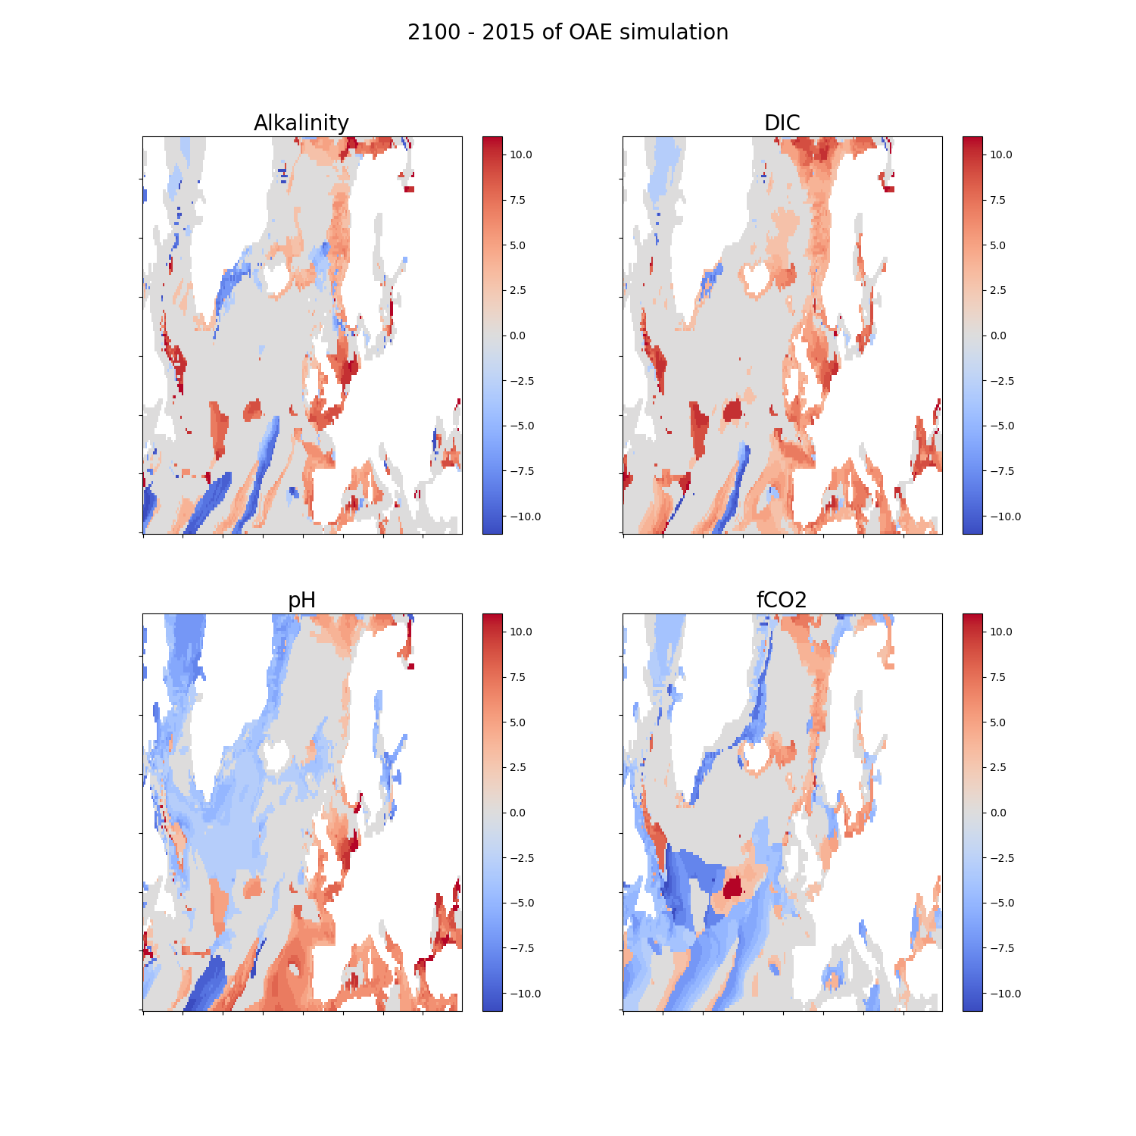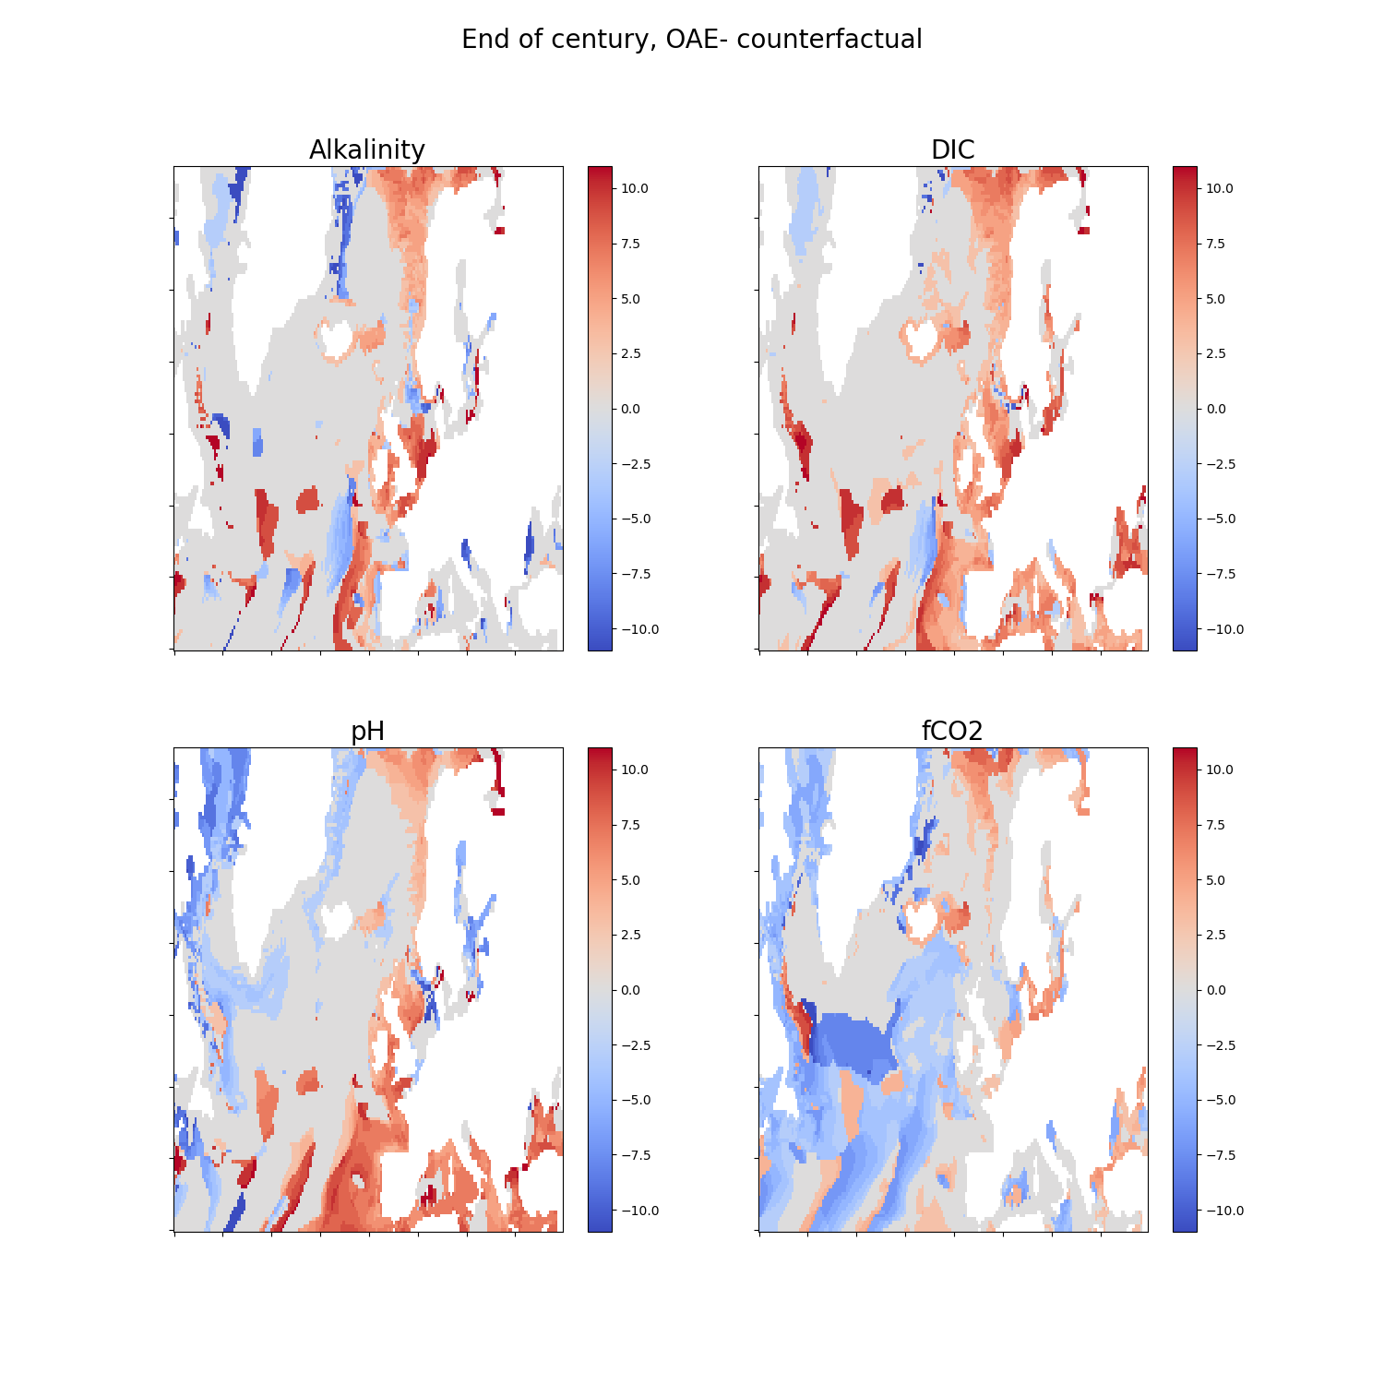

Discussion
Adding alkalinity continuously throughout the year will impact the mean state of the carbonate system in the region of addition, but it also impacts the annual variability due to seasonality in the mixed layer. This can lead to weakening or even reversal of the seasonal cycle, which could have impacts on local ecology. Research is necessary to understand the resilience of local biology to changing seasonality to understand the full implications of weakening or reversing seasonality in a region, but an understanding of how seasonality may change, coupled with an understanding of the dependence of local species and ecosystems on seasonal cycles, could be used to provide guardrails for the implementation of OAE in a region.
The changing of seasonal cycles in response to addition of alkalinity can also inform effective MRV. Measurements, and modelling, of carbon system parameters in the ocean are subject to variability and noise, which obscures the signal of OAE in a region and lengthens the number of years of data necessary to establish a solid baseline. If implementing OAE in a region triggers the reversal of the seasonal cycle in carbon system parameters, this may be a way of seeing departure from the baseline state with less observational data, because only one seasonal cycle of observations will be necessary for comparison to understand where the signal of alkalinity addition is strong. It is worth noting that more detailed modelling will be necessary to quantify removed carbon, but knowing where the seasonal cycle is altered can help to direct where modelling, or further observational, efforts should be focussed.
Understanding the existing seasonal cycle in a region, and how this is impacted by OAE, can therefore provide important information for implementation of OAE. Timing the addition of alkalinity to the point in the seasonal cycle where the signal in measured or modelled parameters will be strongest lends itself to the aim of maximising resources. For example, a shallower summer mixed layer causes a more concentrated alkalinity signal at the surface, which would lead to a more favourable signal to noise ratio. Conversely, timing addition to minimise the effect on the seasonal cycle, thus local species and ecosystems, may be necessary to stay within the guardrails of environmentally safe deployment. For different regions, with different buffer capacities and circulation dynamics, the trade-off between these two factors will be different - so annual average monitoring may not be sufficient to inform responsible and effective deployment.
Figures \EU_mxl and \SCS_mxl also show that some added alkalinity is lost from the mixed layer as it deepens in winter. This shows that seasonal dynamics of the mixed layer in a region also have implications for the efficiency of alkalinity addition as a CDR method, not just the ease of monitoring its impacts.
- Why are the impacts on the seasonal cycle in non-alkalinity things different? Circulation, drivers of seasonality (strength of each pump)?
- Seasonal bias in FOCI?
- Possible to check overshoot runs to see what happens with DAC (i.e. CDR with no BGC changes)?
  - Consider for future research probably - what would this tell us that is missing here, why recommend it
For this study we considered continuous deployment of alkalinity along large stretches of coastline in the North Sea/North Atlantic, or the entire EEZ in China. While studies like this can provide a large-scale, long-term picture of the implications of alkalinity enhancement, future work would benefit from considering point-source/small scale applications of OAE which are more in-line with feasible short-term futures of OAE. Simulating seasonal addition of OAE rather than continuous can also shed further light on how the seasonal cycle can be used in different locations to optimise efficiency, detectability and ecological safety of alkalinity enhancement.

Conclusions

